**CSCI 2302**

**Object-Oriented Thinking Chapter**

**String Lab**

Contents

Intro 1

Learning Goals 1

Notes 1

Task 1

Submit 3

Intro: The term string means an ordered sequence of characters. This sequence of characters can be represented using an object. Strings are widely used in OOP.

Learning Goals: To comprehend and apply the methods in Java’s String class and so we can select and apply the correct methods.

Notes: Please see the Java String Notes.docx file and .java examples.

Task: Complete the steps outlined below in a file named YourmysfaUserName_StringLab.java.

1. Look up and print to the screen how many constructors there are for the String class from Oracle’s documentation.
2. Print to the screen whether the String class is mutable or immutable. State what is returned each time a method that changes the String is invoked in the String class.
3. Print to the screen (explain to me) the difference between a literal String (interned string) and a String object.
4. Create/Instantiate a String *object* with the value CSCI 2302 and print it to the screen.

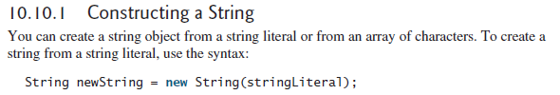

1. Invoke the toString method on the variable from #4, display the returned value to the screen.
2. Create an *interned* string/String literal with the value of CSCI 2302 and print it to the screen.



1. Invoke the toString method on the variable from #6, display the returned value to the screen.
2. Create a String literal with the value of: 1302,2302,2311,2314,3302,3323.
3. Create a String array with the String value created in step 8 using the comma (,) as the split method argument.

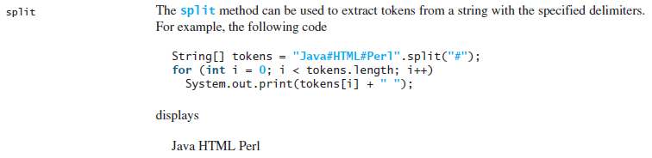

1. Print the array to the screen.
2. Print to the screen the ways one can compare Strings.
3. Print to the screen the pros and cons for each way to compare Strings.
4. Compare the Strings created in steps 4 & 6 in each of the 3 ways. Make a comment of each statement what is happening with each comparison.
5. Create a string with the value of Mississippi and complete the next steps with this string:
   1. State to the screen the first occurrence of the letter i.



Or



* 1. State to the screen the last occurrence of the letter i.



Or



* 1. Replace the i with a.



* 1. Replace the ss with xx.



* 1. Replace the first p with m.



* 1. Replace all ps with qs.



1. Create a String with the value of Lumberjacks, then create a String with the value of Ladyjacks. Complete the next steps using these two strings.
   1. See if the strings start with L.



* 1. See if the strings end with jacks.



* 1. See if the strings contain the String jack.



1. Create a String with the value of Texas, complete the next steps with this string:
   1. Create a substring so the new string contains the value of exa.

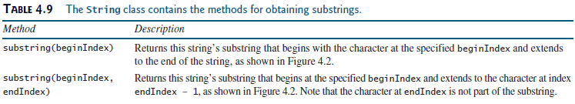

* 1. State to the screen if the Texas string contains the exa string.



Submit: Submit your YourmysfaUserName_StringLab.java file in the Dropbox in Brightspace by D2L.